大学生电子化学习接受程度影响因素调查研究



重庆大学课程论文

学生姓名：韩昊辰

任课教师：张梅教授

课程名称：英语学术论文写作

英语班级：001班

**2023年5月**

**A Research on the Factors Affecting E-learning Acceptance of College Students**



Course Paper Submitted to Chongqing University

**By**

**Han Haochen**

**Supervised by Professor Zhang Mei**

**Academic English Writing**

**English Class: 001**

**May 2023**

# 摘要

如今，电子学习已经成为全国各个高校广泛应用的教学模式，学生对电子学习的接受度也深刻影响着他们电子学习的效率。在中国疫情全国范围放开后，高校全面推行线下教学已有近半年，学生电子学习接受度有什么变化成为新的关注点，但在中国西部鲜有相关的针对性的调查。

本研究使用研究问卷和深度访谈的方法，从感知有用性，感知易用性和系统使用三个方面调查了大学生电子学习接受度，中国西部高校不同年级，不同专业的64名本科生接受了调查，大部分来自重庆某计算机学院。同时本研究基于技术接受模型得到了电子学习接受度的7个影响因素，并通过相关性分析得到了这些因素对感知有用性，感知易用性和电子学习接受度的影响程度，结合实际情况解释了各个因素的影响机理。

结果表明，尽管大部分调查者认为电子学习的过程有挑战性，各个专业的调查者都有乐观的电子学习接受度，可以熟练使用电子学习设备并自主通过网络获取知识，这种趋势随着年级增加而提高。在所有电子学习影响因素中，内容质量，系统自我效能，感知娱乐性对电子学习接受度有着显著影响。

本研究揭示了当前重庆某高校学生电子学习的现状，验证了该校推行电子学习模式的成效，为学生、老师、教育机构、电子平台提供了有数据支撑的建议。

**关键词：**电子学习；技术接受模型；相关性分析；接受度；大学生

**Abstract**

Nowadays, e-learning has become a teaching model widely used in colleges and universities all over the world and students' acceptance of e-learning has a profound impact on their e-learning efficiency. After the nationwide release of the epidemic in China, offline teaching has been fully implemented in colleges for nearly half a year, and the change of students' e-learning acceptance has become a new concern. However, there’s a lack of targeted research in western China.

This study applied questionnaires and in-depth interviews to investigate the acceptability of e-learning among college students from three aspects: perceived usefulness, perceived ease of use and system use. Sixty-four undergraduates from different grades and majors in western China were surveyed, most of whom were from a school of computing in Chongqing. At the same time, based on the technology acceptance model (TAM) and correlation analysis, seven factors affecting e-learning acceptance and their influence degrees were obtained. The influence mechanism of each factor were then explained.

The results show that although most respondents consider the process of e-learning challenging, respondents of all majors have optimistic acceptance of e-learning and can use e-learning equipment proficiently and acquire knowledge through the network independently. This trend increases with the increase of grade level. Among all the factors affecting e-learning, content quality, system self-efficacy and perceived entertainment have significant influence on the acceptance of e-learning.

This study reveals the current situation of e-learning of students in a university in Chongqing, verifies the effectiveness of e-learning mode in the university, and provides data-supported suggestions for students, teachers, educational institutions and electronic platforms.

**Key words:** E-learning; TAM; Correlation Analysis; Acceptance; College students

# Table of Contents

**摘要 3**

**Abstract 4**

**Chapter 1 Introduction 7**

**1.1 Background of the study 7**

**1.1.1 Increasing focus on e-learning acceptance 7**

**1.1.2 Research gap and necessity 8**

**1.2 Hypothesis and research question 8**

**1.2.1 Definition of e-learning 8**

**1.2.2 TAM module 9**

**1.2.3 External variables of TAM 9**

**1.2.4 Definition of e-learning acceptance 10**

**1.3 Research methods 10**

**1.4 Research purpose 10**

**Chapter 2 Research Methodology 11**

**2.1 Research questions 11**

**2.2 Participants 11**

**2.3 Instruments 12**

**2.3.1 The source of the scale 12**

**2.3.2 The formation of the scale 13**

**2.3.3 Scale scoring standards and principles 13**

**2.4 Data collection 13**

**Chapter 3 Data analysis 13**

**3.1 Hypothesis 14**

**3.2 Symbols 14**

**3.2 Data preprocessing 14**

**3.3 Identity analysis 15**

**3.3.1 Score of variables 15**

**3.3.2 Correlation analysis 15**

**3.2 Difference analysis 17**

**Chapter 4 Results and Discussion 18**

**4.1 Results and discussion for research question one 19**

**4.2 Results and discussion for research question two and three 20**

**4.2.1** **Design characteristics 21**

**4.2.2** **User characteristics 21**

**4.3 Summary 22**

**Chapter 5 Conclusion 23**

**5.1 Major findings 23**

**5.2 Implications 23**

**5.3 Limitations 24**

**5.4 Suggestion for future research 24**

**Acknowledgments 25**

**References 26**

# Chapter 1 Introduction

## 1.1 Background of the study

## 1.1.1 Increasing focus on e-learning acceptance

 Since the beginning of this century, the continuous development of information technology has challenged the traditional teaching mode. The voice of combining the new technology with the teaching content is getting louder (Ginns & Ellis 2007). The use of electronic devices and network platforms for teaching is not limited by time and space, and COVID-19 also makes electronic learning(e-learning) the only feasible teaching means. In recent years, the trend of e-learning in Chinese universities has become increasingly significant. Various teaching platforms such as MOOCs, Ismart and Rain Class have been widely used, which provides an opportunity for the research to study the acceptance of e-learning among college students. There is a close relationship between e-learning acceptance and e-learning. Tsain Lin (2001) believes that students' acceptance of e-learning directly determines their learning behaviors and effects. In the last decade, there has been an increasing interest in the factors affecting e-learning acceptance. Exploring these factors can improve the efficiency of students' e-learning, and provide constructive suggestions for schools, teachers and electronic platforms to optimize the education model.

Figure MOOC platform

## 1.1.2 Research gap and necessity

Since the e-learning acceptance carries great significance, many previous researches on it have been conducted at home and abroad. However, most of the research were carried out before the full liberalization of pandemic in China, which may not truly reflect the current e-learning acceptance among Chinese college students.

On December 7, 2022, China was fully released from the epidemic control system, marking the transition of students from the mode of comprehensive online learning and combination of online and offline learning during the epidemic to the mode of comprehensive offline learning. In this context, it is reasonable to believe that students' attitude towards e-learning has changed. Before, students were required to take online courses by the school, so they were more forced to accept e-learning. Now, students have more autonomy to choose whether to e-learn and how to e-learn. It is unknown whether students can keep effectively using electronic devices and media to improve learning efficiency. There has been a dearth of research on this issue since the liberalization of pandemic in China.

In Chongqing University, the difference of students' e-learning acceptance is obvious. This gap is more prominent in students of different majors and grades. Therefore, it is very necessary to explore factors affecting e-learning acceptance in Chongqing University.

## 1.2 Hypothesis and research question

### 1.2.1 Definition of e-learning

E-learning is defined as ‘‘a method of teaching and learning that fully or partially signifies the educational model used, based on the use of electronic media and devices as tools for enhancing availability of training, communication, and interaction, and that helps in accepting novel ways of com-prehending and establishing learning’’ (Krishnan, 2017). According to this definition, the key elements of e-learning are electronic media and devices, with the purpose of improving the effectiveness of learning, which helps us to conclude the factors affecting e-learning acceptance.

### 1.2.2 TAM module

The Technology Acceptance Model (TAM) proposed by Davis (1989) has been employed in various researches of e-learning acceptance and has proved its effectiveness as compared with the other theoretical models (Qaysi, 2018). This research apply TAM to study the e-learning acceptance of students in CQU.

According to TAM, two personal beliefs will affect the attitude towards e-learning. One is perceived usefulness(P), which indicates whether one thinks e-learning is useful. Another is perceived ease of use(E), which indicates one thinks how easy e-leaning is to use. Perceived usefulness and attitude toward using will both affect behavior intention to e-learning(BI), which finally determine the actual system use(AU). The variables mentioned above act as determining variables in TAM.

### 1.2.3 External variables of TAM

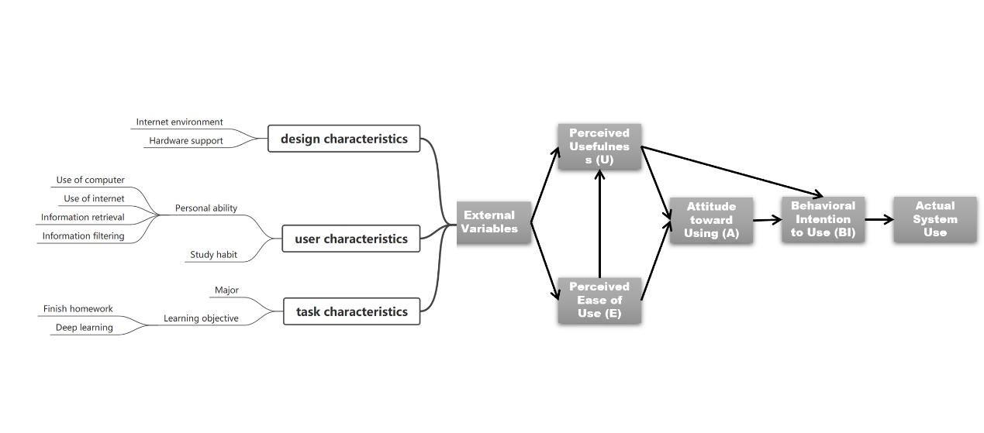Davis(1989) considered that many external variables affect two personal beliefs in TAM. Abdullah and Ward (2016) identified 152 external factors by reviewing 107 published articles in the duration of ten years. They abstracted the characteristics of three external variables, namely design characteristics, user characteristics and task characteristics. Based on their research and the preliminary observation of this research, external variables are further refined into several factors (see figure 2). Those are the factors that we're looking at, factors affecting e-learning acceptance. The research question is to study the impact of these factors on e-learning acceptance and how to explain the impact of different factors.

Figure TAM and external variables

### 1.2.4 Definition of e-learning acceptance

There are few specific definitions of e-learning acceptance in past literature. In this study, college students’ actual use of e-learning is mainly focused on. According to TAM model(Davis, 1989), actual system use has a strong relationship with perceived usefulness and perceived ease of use. Therefore, actual use of e-learning, perceived usefulness and perceived ease of use will all be considered to define e-learning acceptance.

## 1.3 Research methods

This study uses a questionnaire to study e-learning acceptance. Factors affecting e-learning acceptance will be specific in the form of questions. The questionnaire will be released on a software called "问卷星". It is expected that 70 people will be covered, among which 50 will be students of various majors and grades in Chongqing University. In order to make the research more generalized, no more than 20 questionnaires will be sent to non-Chongqing University students. The questionnaire will collect students' majors, grades and their self-evaluation of e-learning acceptance as well as their specific performance in factors affecting e-learning. The answers to the questions will be designed by likert scale. The answers to questions related to different factors are used as one of the scores for each factor. Finally, the score of each factor is summarized, and the average value is taken for principal component analysis and linear fitting.

## 1.4 Research purpose

This study aims to explore the influence of different factors on e-learning acceptance, discuss the results and explain the internal relationship of such influence.

The results of this study can provide constructive suggestions supported by data for schools, teachers, students and e-learning platforms. This project divides the student groups according to different e-learning acceptance, considering grade, major and other factors, so that the teaching administrator can cross the restrictions of his own discipline and explore the e-learning acceptance of the entire student group from a broader research perspective. So that they can generally innovate teaching mode and popularize e-learning.

At the same time, this project excavates the factors that have a great influence on students' e-learning, which can help teaching managers focus on some more practical points in the complicated schemes for the popularization of e-learning and the improvement of teaching mode, making targeted teaching schemes.

# Chapter 2 Research Methodology

In this section, the research questions, subjects and instruments are introduced.

## 2.1 Research questions

Around the e-leaning acceptance of college students, this study intends to discuss the following 3 questions:

1. What are the differences in e-learning acceptance among students of different genders, grades, majors and academic performance?
2. What are the factors affecting e-learning acceptance? What’s the relevance of these factors with the influence of e-learning acceptance?
3. How to explain the influence mechanism of each factor on the e-learning acceptance?

## 2.2 Participants

The questionnaire are used in this study. 64 participants were investigated, among whom 59 were students of Chongqing University and 5 were students of other schools. Participants were aged between 16 and 24, the majority of whom were current freshmen, sophomores and juniors. 60.94% participants were computer science students, while the rest included students from a variety of disciplines, including natural sciences, medicine, social sciences, and humanities. Demographic information is shown in the table below

Table Demographic

|  |  |  |  |  |  |
| --- | --- | --- | --- | --- | --- |
| Participants: | 64 |  |  |  |  |
| Grade | **Freshmen** | **Sophomores** | **Juniors** | **Others** |  |
|  | 8(12.5%) | 44(68.75%) | 10(15.63%) | 2(3.12%) |  |
| School | **Cqu** | **Non-cqu** |  |  |  |
|  | 59(92.19%) | 5(7.81%) |  |  |  |
| Major | **Computer sciences** | **Engineering (non-computer major)** | **Mathematical science** | **Humanities** | **Others** |
|  | 39(60.94%) | 10(15.63%) | 4(6.25%) | 7(10.94%) | 4(6.25%)) |
| Gender | **Female** | **Male** |  |  |  |
|  | 23(35.94%) | 41(64.06%) |  |  |  |

Prior to analyze the final data collected from the questionnaire, an interview is carried out to test the reliability of the questionnaire items.

## 2.3 Instruments

The questionnaire were the main instrument in the study. The source, formation, standard of the scale are mentioned in this section.

### 2.3.1 The source of the scale

The questionnaire constructed by this research mainly refers to the questionnaire made by Salloum(2019) in his research on the acceptance of students in the United Arab Emirates on their school learning system. He integrated the emphases of relevant previous research questionnaires, which has reference significance for this research. At the same time, the questionnaire of this study has been improved on Salloum in view of the characteristics of students and learning platforms in Chongqing University and other Chinese universities.

### 2.3.2 The formation of the scale

The questionnaire is divided into three parts. The first part collects participants' personal information. The second part includes the usage of e-learning system. The third part involves the factors affecting e-learning acceptance.

### 2.3.3 Scale scoring standards and principles

The questionnaire adopts Likert scale. The questions are composed of a set of statements, and each statement has five answers ranging from strongly disagree to strongly agree, with a score of 1 to 5. The total score of each respondent's attitude is the sum of the scores he received for his answers to each question.

The criterion of the scale is that the questionnaire needs to cover multiple aspects, and each question is equally important, with clear meaning, and can measure the subject correctly and accurately. At the same time, it is necessary to eliminate the interference of subjective factors to ensure the stability of the result evaluation. Finally, it is necessary to adjust the scale according to needs in specific research projects to adapt to different purposes and needs of audiences.

## 2.4 Data collection

The data collection was carried during 023/4/10 and 2023/4/20 by distributing questionnaire on “问卷星” in Universities in Sichuan and Chongqing. Overall, 100 questionnaires were circulated among the students. 64 questionnaires were recycled. Out of these, only 1 questionnaire were not considered due to the large number of abnormal values. Subsequently, 63 questionnaires were evaluated, providing 63% response rate and the reliability of the data was guaranteed.

# Chapter 3 Data analysis

This study employs the correlation analysis to analyze the variables affecting e-learning acceptance, using python. Correlation analysis refers to the analysis of two or more variable elements with correlation, so as to measure the degree of correlation between two variable factors.

## 3.1 Hypothesis

For better research, the following assumptions are made in this study:

1. The results collected by the questionnaire can correctly reflect the situation of variables.
2. The degree of correlation between external variables is negligible.
3. There is a linear relationship between the determining variable and the external variable, and both conform to normal distribution.

## 3.2 Symbols

The symbols defined in this study are shown in table

Table 2 Symbols and definitions

|  |  |
| --- | --- |
| Symbol | Definition |
| AU | Actual Use |
| PU | Perceived Usefulness |
| PE | Perceived Ease of Use |
| SQ | System Quality |
| CQ | Content Quality |
| CS | Computers Self-Effeciency |
| CE | Computer Environment |
| SN | Subjective Norm |
| PEn | Perceived Enjoyment |
| PA | Perceived Accessibility |

## 3.2 Data preprocessing

There are 17 questions in the questionnaire, among which 4 questions collect personal information, 3 questions are related to TAM determinant variables (AU,PU,PE), and 10 questions are related to external TAM variables. Likert scale was adopted for questions related to variables. The answers to the questions ranged from 1 to 5 points, which were used as the scores of the corresponding variables.

Among the ten questions related to external variables, 4 questions corresponded to only one external variable, and 6 questions corresponded to three external variables, among which each variable corresponded to two questions. The scores of the answers to the two questions were averaged and used as the scores of the corresponding variables.

As for the processing of abnormal values, among the collected questionnaires, there was only one questionnaire whose answers were all 5 points, which was removed as abnormal values. Finally, 63 valid questionnaires were collected for data analysis.

## 3.3 Identity analysis

Identity analysis is conducted from the total score of variables and correlation analysis**.**

### 3.3.1 Score of variables

According to the statistical data of the questionnaire, the score of each variable were obtained (see table 2).

Table 3 Score of each variable

|  |  |  |  |  |  |  |  |  |  |  |  |  |  |
| --- | --- | --- | --- | --- | --- | --- | --- | --- | --- | --- | --- | --- | --- |
|  | **AU** | **PU** | **PE** | **SQ** | **CQ** | **CS** | **CE** | **SN1** | **SN2** | **PEn1** | **PEn2** | **PA1** | **PA2** |
| **Mean** | 4.046875 | 4.203125 | 3.6875 | 2.921875 | 3.703125 | 3.53125 | 3.921875 | 3.90625 | 2.859375 | 3.125 | 3.3125 | 4.40625 | 3.90625 |
| **Variance** | 1.410466 | 1.2438 | 1.392857 | 1.279514 | 1.196181 | 1.237103 | 1.057292 | 1.102183 | 1.519593 | 1.380952 | 1.361111 | 0.816468 | 1.006944 |

The mean scores of the three determine variables are all over 3.5, but the variance of AU and PE are around 1.4. Among all external variables, PA has the highest average score, SQ has the lowest, SN has the highest variance, and PA has the lowest.

### 3.3.2 Correlation analysis

Correlation analysis was used in this study. Since it is assumed that there is a linear relationship between variables and variables conform to normal distribution, Pearson correlation coefficient is selected as the correlation coefficient. The correlation strength of variables is judged by the absolute range of correlation coefficient:

* 0.8-1.0 very strong correlation
* 0.6-0.8 strong correlation
* 0.4-0.6 moderate correlation
* 0.2-0.4 weak correlation
* 0.0-0.2 very weak correlation or no correlation

The correlation coefficient between the obtained variables is shown in the table

Table 4 correlation coefficient between variables

|  |  |  |  |  |  |  |  |  |  |  |
| --- | --- | --- | --- | --- | --- | --- | --- | --- | --- | --- |
|  | AU | PU | PE | SQ | CQ | CS | CE | SN | PEn | PA |
| AU | 1 | 0.615867 | 0.644797 | 0.10911 | 0.585235 | 0.521588 | 0.483977 | 0.33442 | 0.383881 | 0.29067 |
| PU | 0.615867 | 1 | 0.63991 | 0.289591 | 0.739925 | 0.500252 | 0.387782 | 0.442621 | 0.515504 | 0.255461 |
| PE | 0.644797 | 0.63991 | 1 | 0.266783 | 0.603334 | 0.600072 | 0.528924 | 0.276067 | 0.417007 | 0.444227 |
| SQ | 0.10911 | 0.289591 | 0.266783 | 1 | 0.417187 | 0.285839 | 0.281258 | 0.314466 | 0.159399 | 0.152863 |
| CQ | 0.585235 | 0.739925 | 0.603334 | 0.417187 | 1 | 0.653645 | 0.515398 | 0.447457 | 0.512574 | 0.332513 |
| CS | 0.521588 | 0.500252 | 0.600072 | 0.285839 | 0.653645 | 1 | 0.480995 | 0.427928 | 0.63154 | 0.445914 |
| CE | 0.483977 | 0.387782 | 0.528924 | 0.281258 | 0.515398 | 0.480995 | 1 | 0.345939 | 0.217124 | 0.378813 |
| SN | 0.33442 | 0.442621 | 0.276067 | 0.314466 | 0.447457 | 0.427928 | 0.345939 | 1 | 0.496903 | 0.341215 |
| PEn | 0.383881 | 0.515504 | 0.417007 | 0.159399 | 0.512574 | 0.63154 | 0.217124 | 0.496903 | 1 | 0.471773 |
| PA | 0.29067 | 0.255461 | 0.444227 | 0.152863 | 0.332513 | 0.445914 | 0.378813 | 0.341215 | 0.471773 | 1 |

Since AU, PU and PE were used to define e-learning acceptance in this study, the correlation coefficients between each external variable and determining variable were added and averaged to obtain the correlation between external variable and e-learning acceptance, as shown in the figure.

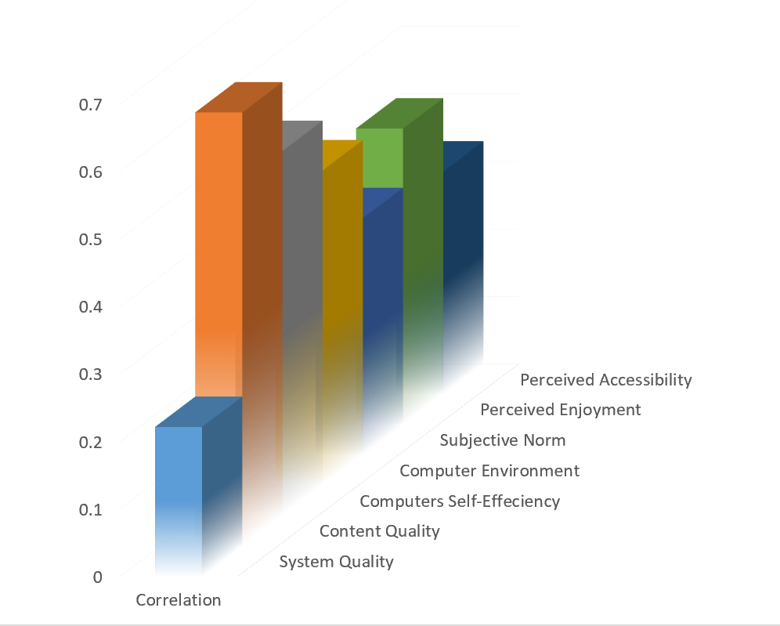

Figure 3 correlation between external variables and e-learning acceptance

The results show that Content quality has the highest correlation coefficient (0.64), followed by Computers Self-efficiency (0.54) and System quality has the lowest correlation coefficient (0.22).

## 3.2 Difference analysis

In order to explore the differences in e-learning acceptance among students of different genders, grades and majors, this study conducted statistics on the scores of AU,PU and PE based on the different attributes of these three aspects, and added the three scores together as the total score of each attribute on e-learning acceptance. The following table is obtained:

Table 5 e-learning acceptance of different attribute

|  |  |  |  |  |  |  |  |  |  |  |  |  |
| --- | --- | --- | --- | --- | --- | --- | --- | --- | --- | --- | --- | --- |
| Attribute | | | Num | | Actual Use | | Perceived Usefulness | | Perceived Ease of Use | | Score | |
| Gender | | Male | 41 | | 4.097560976 | | 4.292682927 | | 3.707317 | | 12.09756 | |
| Female | 23 | | 3.956521739 | | 4.043478261 | | 3.652174 | | 11.65217 | |
| Grade | | Freshmen and Younger Stu. | 9 | | 3.444444444 | | 4 | | 3.222222 | | 10.66667 | |
| Sophomores | 44 | | 4.165432099 | | 4.155555556 | | 3.738272 | | 12.05926 | |
| Juniors and Older Stu. | 11 | | 4 | | 4.545454545 | | 3.818182 | | 12.36364 | |
| Major | | Computer sciences | 39 | | 4.205128205 | | 4.230769231 | | 3.794872 | | 12.23077 | |
| Engineering (non-computer major) | 10 | | 3.6 | | 4.1 | | 3.4 | | 11.1 | |
| Mathematical science | 4 | | 4.75 | | 4.75 | | 3.75 | | 13.25 | |
| Humanities | 7 | | 3.714285714 | | 4.714285714 | | 3.714286 | | 12.14286 | |
| Economics, management and medicine | 4 | | 3.5 | | 2.75 | | 3.25 | | 9.5 | |

Visualize the data to get the figure below.

Figure 4 Score of e-learning acceptance

The results show that the score of male students is slightly higher than that of female students, and the score increases with the growth of grade. In different majors, mathematical science scores the highest, followed by computer science, engineering and humanities with similar scores, and finally economics, management and medicine, whose score is low.

# Chapter 4 Results and Discussion

Based on the results of data analysis, this chapter will discuss the general situation of e-learning acceptance among students, the influencing factors and their influence degrees, and the differences of e-learning acceptance among different types of students. The discussion will proceed in the order of research question.

## 4.1 Results and discussion for research question one

Research question one is what the differences in e-learning acceptance among students of different genders, grades, majors and academic performance are?

In terms of gender, the study shows that there is little difference in e-learning acceptance between males and females, with males scoring slightly higher than females (12.1 points for males and 11.65 points for females). However, considering that this difference may be accidental, since the number of male students filling out the questionnaire is about twice that of female students, and the total number of students filling out the questionnaire is not large (63), the differences in e-learning acceptance caused by gender differences will not be discussed in depth.

In terms of grades, the study shows that the acceptance of e-learning increases with the growth of grades. The score of freshmen is the lowest, only 10.67, and then rises to 12.06 in sophomore year, and finally slightly rises to 12.36 in junior year. This result shows that freshmen may be still in the transition from paper learning to e-learning in high school, and many students still prefer the learning mode they are familiar to in high school. However, universities have higher requirements on students' self-study and e-learning, and many students find that e-learning can improve their learning efficiency, hence they increasingly accept e-learning.

In terms of majors, the study shows that there is little difference in the acceptance of e-learning among different majors. The score of computer majors is 12.23 while that of humanities majors is 12.14. According to the in-depth interviews with students of law major in this study, even for many liberal arts majors, teachers have high requirements on e-learning. Students are often required to learn online courses by themselves and find online resources. Most students use tablet computers to take notes directly on the teacher's ppt through note-taking app on a regular basis. However, this result is not significantly representative, because the questionnaire covers only a small number of liberal arts students (11), and most of the liberal arts students are of law majors.

Due to privacy concerns, the study did not involve an analysis of the correlation between academic performance and acceptance in the electronics department.

## 4.2 Results and discussion for research question two and three

Research question two and three are what the factors affecting e-learning acceptance are, what the relevance of these factors with the influence of e-learning acceptance is and how to explain the influence mechanism of each factor on the e-learning acceptance.

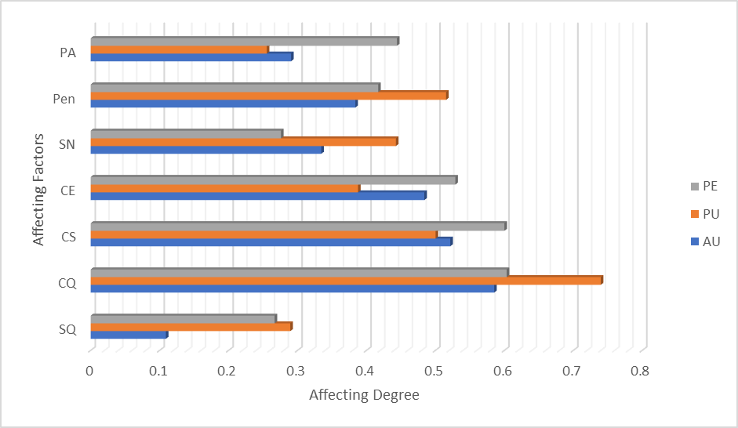

Figure Affecting factors and their affecting degree

The affecting factors and their affecting degree to perceived usefulness, perceived ease of use and actual use are shown in the figure. Content quality, computer self-efficiency and perceived enjoyment act as the three factors with the highest influence on e-learning acceptance and will be heavily discussed.

The results are discussed from design characteristics and user characteristics.

### Design characteristics

In terms of design characteristics, the results show that system quality has little influence on e-learning, whether it is perceived usefulness or perceived ease of use, which is inconsistent with the research of Said A. Salloum in 2019. Considering the mean score of system quality attribute on the questionnaire (2.92) and its corresponding question in the questionnaire (how satisfied you are with the e-learning platform in China), it can be concluded that there is wide appeal for improving the current e-learning platform. Relevant platforms should constantly improve their page simplicity, operability and user friendliness to respond to the e-learning needs of college students.

However, the results also show that content quality has a significant impact on e-learning acceptance, indicating that the increasing reserves and richness of online knowledge year by year has a positive impact on students' e-learning acceptance, and students can effectively acquire online knowledge under the condition of low system quality score. This is related to the improvement of students' self-study ability in Chongqing University.

Computer environment also has a certain impact on e-learning acceptance, which indicates that if students' daily learning hardware facilities such as computers, mobile phones and network environment meet the requirements, students are more willing to accept e-learning. Schools can continuously optimize campus network environment and electronic equipment environment to promote the popularization of e-learning.

### User characteristics

Studies have shown that subjective norm has a certain impact on perceived usefulness, but not on perceived ease of use and actual e-learning use, which is different from previous studies which found that the subjective norm has no significant impact on perceived usefulness. The results indicates that students' opinions on the usefulness of e-learning in Chongqing University are still affected by teachers' and classmates' opinions, which may be related to teachers' encouragement of e-learning. But even if people around them think e-learning is sound, students will not necessarily believe that e-learning is easy and increase the actual frequency of use.

The results show that perceived enjoyment has certain influence on both perceived usefulness and perceived ease of use, suggesting that when students show a positive trend of spontaneous interaction with e-learning, their acceptance of e-learning will certainly increase. The electronic platform can enhance the interaction between its system and users, and change the teaching mode of the platform, so that it is not only a one-way transmission of knowledge, but a two-way interaction full of games, creativity and curiosity.

Finally, the results show that perceived accessibility has a significant positive influence on perceived ease-of-use but has little influence on perceived usefulness, indicating that when students have enough confidence and skill in using e-learning, they will believe that e-learning is easy to use. Teachers and platforms can enhance the transmission of using skills of some electronic tools, dispel students' fear of new electronic tools, and enhance encouragement and guidance to enhance students' perceived accessibility

**4.3 Summary**

In general, according to the result of variable score statistics, students in Chongqing University have a positive e-learning acceptance and frequency in using e-learning in daily life. However, quite a few students still consider it difficult to use e-learning. The e-learning acceptance of male students is slightly better than that of female students, and it gets better as the grade increases. There is little difference in e-learning acceptance among different majors. Even the liberal arts have similar e-learning acceptance as the science. Among all the external factors that affect the acceptance of e-learning, content quality, computers self-efficiency have significant influence. Perceived enjoyment and computer environment have certain influence. Perceived accessibility, subjective norm and system quality have little impact.

# Chapter 5 Conclusion

In general, this study reveals the general situation after the complete release of the epidemic in China, of e-learning acceptance among students in Chongqing University, especially those majoring in computer science. The influencing factors of e-learning acceptance and the connections and reasons behind it are also explored. It provides constructive suggestions for schools and electronic platforms. However, there are still many improvements in this study.

## 5.1 Major findings

This study shows that at present, students of all majors and grades in Chongqing University have optimistic e-learning acceptance, and with the growth of grade, students' e-learning acceptance has improved. This reveals that Chongqing University is effective in cultivating students' e-learning ability. Meanwhile, content quality, computer self-efficiency and perceived enjoyment all have significant positive effects on e-learning acceptance, which deserves the attention of relevant organizations such as schools and electronic platforms.

## 5.2 Implications

The results provide a deeper understanding of external factors and provide useful suggestions for schools, students, teachers and e-platform designers to effectively adopt e-learning systems. First, university administrations need to optimize the e-learning system infrastructure and assess student readiness for e-learning systems. Second, decision makers and managers of e-learning platforms need to focus on the factors that play a role in increasing student acceptance of such systems, which in turn affect teaching performance and student effectiveness. Third, the findings show how important external factors related to student acceptance of e-learning systems are. Students' perception of the ease of use and usefulness of e-learning systems should therefore be encouraged, as this will improve students' computer accessibility and computer self-efficiency and then subsequently improve their use of e-learning systems. Finally, the e-learning platform can enhance user interaction and interest of its own platform, which can enhance students' learning effect by enhancing perceived enjoyment.

## 5.3 Limitations

Although the results of the study were quite interesting and played an essential role in describing the students’ acceptance of e-learning systems, it also posits some limitations. First of all, the number of people and majors covered by the questionnaire is limited, which will be immeasurably different from the actual situation of the whole major and the whole school. Secondly, the questionnaire is mainly distributed through QQ group, and the students who come into contact with the questionnaire may frequently use QQ with a certain extent of computer handling ability, so the sample cannot be absolutely random. Thirdly, limited by the author's ability, the e-learning acceptance survey report conducted efficiently in Chongqing University and even in western China cannot be found. Therefore, this study lacks a longitudinal comparative analysis, and it is difficult to get a comparison between the situation before and after the full liberalization of the epidemic in China. Finally, the study is only for students, and if the reaction of teachers is taken into account, it is possible to compare the analysis between teachers and students. Further research should take this into account.

## 5.4 Suggestion for future research

Further research could consider other sampling techniques. On the one hand it is to further extend the results to the whole population. On the other hand, the selection of e-learning ability of samples by the way of questionnaire delivery itself should be avoided. For example, questionnaires are distributed offline in class. Further research can also take this study as a longitudinal comparison of students' e-learning results in a certain period of time to obtain the changes of students' e-learning over time. Finally, further investigation can be extended to more organizations such as teachers and managers of electronic platforms, so as to explore and improve students' e-learning ability from multiple starting points.

# Acknowledgments

My thanks and appreciation to professor Zhang Mei and her teaching assistant Zeng Yuting for supervising this research. Most of the writing techniques and methods used in this research were learned in Zhang Mei’s class and there were timely and targeted instructions on every chapter of this research after written.

The support of all the students involved in this research is gratefully acknowledged. Special thanks to the law school students for receiving the interview.

# References

1. A. Rhema, “An analysis of experiences and perceptions of technology-based learning in higher education institutions in Libya: Informing the advancement of e-learning,” Ph.D. dissertation, Victoria, Melbourne, VIC, Australia, 2013.
2. Chamberlin, W. S. 2001. Face-to-face vs. cyberspace: Finding the middle ground. Campus Technology
3. F. Abdullah and R. Ward, “Developing a general extended technology acceptance model for e-learning (GETAMEL) by analyzing commonly used external factors,” Compute. Hum. Behavior., vol. 56, pp. 238–256, Mar. 2016.
4. F. D. Davis, ‘‘Perceived usefulness, perceived ease of use, and user acceptance of information technology,’’ MIS Quart.
5. Ginns, P. & R. Ellis. 2007. Quality in blended learning: Exploring the relationships between on-line and face-to-face teaching and learning [J]. The Internet and Higher Education
6. N. Al-Qaysi, N. Mohamad-Nordin, and M. Al-Emran, ‘‘A systematic review of social media acceptance from the perspective of educational and information systems theories and models,’’ J. Educ. Compute. Res.,2018.
7. K. S. T. Krishnan and H. Hussin, ‘‘E-learning readiness on Bumiputera SME’s intention for adoption of online entrepreneurship training in Malaysia,’’ Management, vol. 7, no. 1, pp. 35–39, 2017.

# Appendix

## The content of the questionnaire:

1. 您的性别：

a.男；

b.女；

1. 您所在的年级：

a.高中及以下；

b.大一；

c.大二；

d.大三；

e.大四；

f.研究生及以上

1. 您的专业类别：

a.计算机；

b.工学（非计算机）；

c.理学；

d.哲学，法学，教育学，文学，历史学，艺术学；

e.医学；

f.经济学，管理学；

g.军事学；

4，您的学校：

1. 重庆大学；
2. 非重庆大学

5，(Actual Use)我经常电子学习(包括通过电子设备，电子平台和媒体学习)



6，(Perceived Usefulness)我认为电子学习是有用的



7，(Perceived Ease of Use)电子学习对于我来说很容易



8，(System Quality)对于现在大多数电子学习系统(如雨课堂，慕课)我是满意的



9， (Content Quality)我学到的知识很多来自电子学习



10，(Computers Self-Effeciency)我相信我善于使用手机，电脑等硬件学习



11，(Computer Environment)我目前使用的手机，电脑等学习设备可以满足我电子学习的需要



12, (Subjective Norm)我认为作为一个学生我应该接受电子学习



13,(Subjective Norm)我对电子学习的态度受身边人态度的影响



14.(Perceived Enjoyment)电子学习相比传统学习更有趣



15. (Perceived Enjoyment）我觉得电子学习可以激发我的想象力和好奇心



16. (Perceived Accessibility）我经常在知网，知乎，b站，CSDN等电子系统上检索信息



17. (Perceived Accessibility）我能够有效在电子系统上筛选后获取所需要的信息

